 | 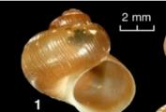
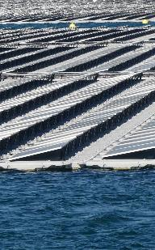 | Albania – KESH Floating PV  Non-technical summary
 | 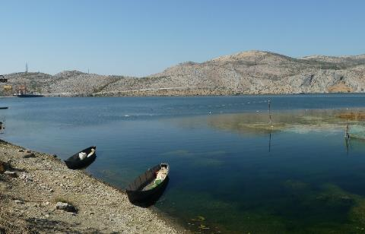

Date: 04.10.2020
Version: B
Reference: 20g09B
Prepared for: EBRD
Project developed by: KESH

Project description

Context
In line with the objectives set by the Albanian Government in the National Energy Strategy 2017-2030 and the National Consolidated Action Plan on Renewable Energy Sources 2019-2020 KESH sh.a. (KESH) is seeking to increase and diversify the generation and trading of energy from its renewable sources, on purpose to increase economic profitability and competitiveness in the domestic or regional market.
In 2018 KESH has prepared a pre-feasibility study on technical and economic terms, for the installation of a floating photovoltaic (PV) plant on the surface of Vau i Dejës reservoir, whose dam and hydropower plant are also managed by KESH. The objective of the Project is to install and operate this floating photovoltaic plant.

Main characteristics
The Project is located on Vau I Dejes artificial reservoir, in the North of Albania, close to Vau i Dejes town (Figure 2). The surface area of the floating PV will be around 12 ha (equivalent to a 350x350m square shape). Compared to the total surface of the reservoir, this represents 0.45% of the total surface of the reservoir.
The installed capacity will of 12.9 MW of peak power: the average annual energy output will be 18855 MWh: this corresponds to the average consumption of a town with 10 000 inhabitants.
The floating PV will be anchored on the bottom of the reservoir (with concrete blocks, augers or similar equipment), linked to the floating PV with underwater cables. The PV farm will take advantage of the proximity of Vau I Dejes hydropower plant, and will therefore have a short connection to the grid. No long or high voltage transmission line will need to be built.
Different locations were assessed for the floating PV. Gomsiqe bay was excluded for both biodiversity conservation and tourism / landscape preservation.
Figure 2 – Floating PV location options
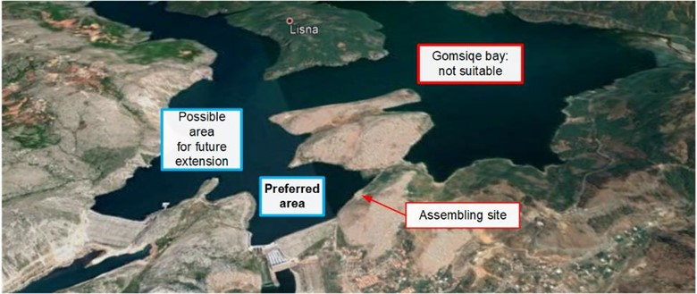

Figure 2 - Project location: general view
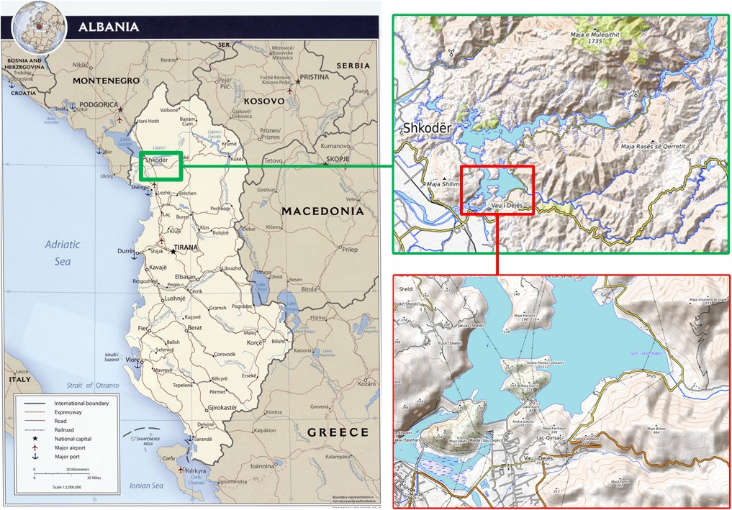

Design, construction and operation
The project is planned to be designed and built through a single EPC contract with KESH. The Project will then be owned and operated by KESH.
The construction will last 8 to 9 months. The main supply route for the Project is expected to be from Durrës harbour, located 100 km from the Project area. The number of staff involved in the construction will be less than one hundred at peak; in average, several tens of staff will be employed during construction.
The area of the existing quay close to Qyrsaqi dam will be used for the construction:
Figure 50 - View of the existing quay close to Qyrsaqi dam
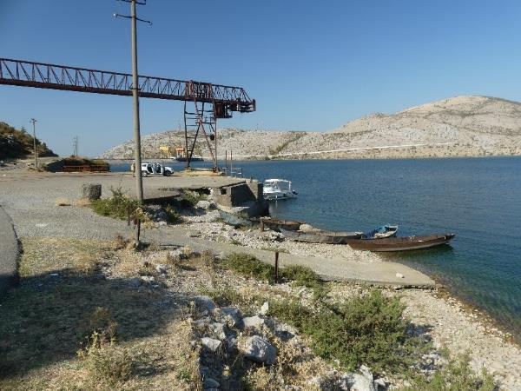
Figure 3 – Visual aspect of a floating PV (Piolenc, France)
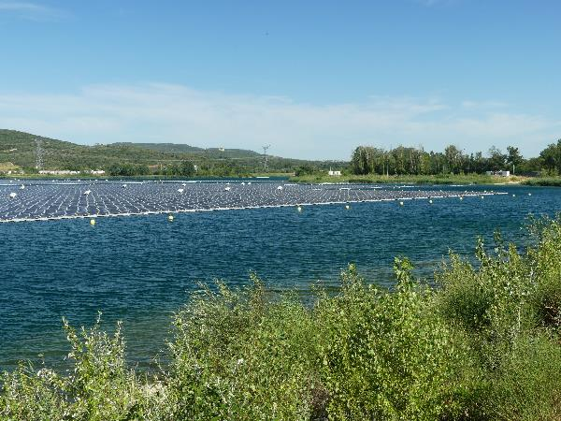
Photovoltaic panels lose their efficiency over the years. The useful life of the floating PV is estimated to 20 years, after what the solar panels efficiency is expected to be below 80%.

Compliance framework

Albanian legislation
The Project will be developed and operated in compliance with the Albanian legislation. A preliminary Environmental Impact Assessment was developed, and will be followed by a detailed Environmental Impact Assessment.

EBRD's Environmental and social policy
The Project is also implemented in compliance with EBRD's Environmental and Social Policy. An environmental and social assessment was undertaken, which showed that:
- The project does not have perceptible impact on critical habitats or the conservation objectives of protected or internationally recognized areas.
- The Project does not require resettlement or any other form of significant and long lasting social impact.
- The Project is not part of the EU EIA Directive / Annex IIa list of projects that require a full ESIA.
The Project is categorized B under EBRD’s 2019 Environmental and Social Policy.

Environmental and social risks and mitigation measures

Environmental risks and mitigation measures
The environmental baseline assessment of Vau I Dejes reservoir that was undertaken showed that:
- The reservoir has a significant nutrient load, and its deeper layers lack oxygen.
- The shallower zones of the reservoir, in particular its shores and the Gomsiqe bay, are the richest ones in terms of biodiversity.
- The reservoir hosts seven species of conservation interest: three mollusc, two crayfish and two fish species.
- The reservoir area where the floating PV is envisaged is outside established protected or internationally recognized areas, but within the eastern extremity of the prospective "IBAT for research" Key Biodiversity Area of "Shkodra Lake – Buna River – Velioja - Vau i Dejes".
The main mitigation measures for biodiversity conservation of the Project include (i) avoidance of the Gomsiqe bay, (ii) collection and relocation of species of conservation interest with lesser mobility (molluscs and crayfish) from the floating PV assembling site, (iii) avoidance of the fish spawning period to start the construction, (iv) avoidance of permanent lighting on the floating PV, (v) fire prevention measures, (vi) development of the scientific knowledge and long term monitoring for species of conservation interest, in view of their inscription in the national red list and update of their information on IUCN website.

Social risks and mitigation measures
The Project does not require any form of resettlement. The Project area is however of interest for tourism and leisure activities. The landscape of Gomsiqe bay is beautiful and is a source of tourism activities (navigation, cafes and restaurants) and should be preserved.
The area that was selected for assembling and installing the floating PV is of lesser visual / landscape value. It is however used to access the reservoir (existing concrete ramp for boats). It is also planned to be part of the development of Vau I Dejes Municipality: the Municipality Territorial Development Plan, approved in 2018 by the National Territorial Council as the supreme planning authority in Albania, foresees different social and economic initiatives at the reservoir. The plan envisages the reservoir as a corridor in order to achieve an integrated tourism itinerary from the Albanian Alps to the Adriatic Sea, which would require the construction of a quay for tourism boats close to the floating PV.
The main mitigation measures for the potential social risks and impacts of the Project include (i) avoidance of the Gomsiqe bay, (ii) the preservation of existing reservoir uses and access across construction and operation, (iii) coordination and formal agreement with the Municipality of Vau I Dejes regarding the floating PV layout, in order to ensure its compatibility with the Territorial Development Plan, (iv) avoidance of disturbances during construction, (v) the construction of a floating fence around the floating PV for public safety, (vi) the implementation of a stakeholder engagement plan, including a grievance mechanism.

Contact
If you are interested by the Project and wish to receive further information, please contact KESH using the following contact details:

Name and position | To be completed by KESH
E-mail | To be completed by KESH
Telephone | To be completed by KESH

