|  |  |  |
| --- | --- | --- |
|  |  |  |
| C:\Users\User\Desktop\Projekti Vau i Dejes\foto konsultime me publikun\IMG_20200623_150952.jpg | Albania – KESH Floating PV  Stakeholder Engagement Plan | |
|  |  | |

Date: 03.11.2020

Version: D

Reference: 20g08D

Prepared for: EBRD

Project developed by: KESH

Abbreviations

|  |  |
| --- | --- |
| CSO | Civil Society Organization |
| EBRD | European Bank for Reconstruction |
| E&S | Environmental and Social |
| EIA | Environmental Impact Assessment |
| ESAP | Environmental and Social Action Plan |
| MoE | Ministry in charge of Environment |
| SEO | Stakeholder Engagement Officer |

Content

[A. Objectives of the SEP 3](#_Toc52720061)

[B. Project description 3](#_Toc52720062)

[B.1 Rationale for the project 3](#_Toc52720063)

[B.2 Project arrangements 4](#_Toc52720064)

[C. Legal framework and requirements 6](#_Toc52720065)

[C.1 National legislative framework for public consultation and information 6](#_Toc52720066)

[C.2 EBRD Requirements 7](#_Toc52720067)

[D. Stakeholders identification and analysis 7](#_Toc52720068)

[E. Summary of stakeholder engagement to date 8](#_Toc52720069)

[E.1 Stakeholder engagement activities during due diligence 8](#_Toc52720070)

[E.2 Media search 9](#_Toc52720071)

[F. Documents/information disclosure and engagement activities 10](#_Toc52720072)

[G. Arrangements for stakeholders engagement 12](#_Toc52720073)

[G.1 Organisation 12](#_Toc52720074)

[G.2 Internal monitoring and reporting 13](#_Toc52720075)

[G.3 Grievance redress mechanism 13](#_Toc52720076)

INTRODUCTION

KESH - the state-owned electricity generator is planning to implement the "Vau i Dejës Floating Solar Project" (the "Project"), located on Vau i Dejës Reservoir, Albania. The Project will entail the construction of a 12.9 MW floating solar photo-voltaic (PV) plant and associated electrical infrastructure, expected to allow a connection with the sub-station at the Vau i Dejës Hydro Power Plant.

The European Bank for Reconstruction and Development (the “EBRD”) is considering providing finance to Kesh for the Project, which is categorised “B” in accordance with the EBRD 2019 Environmental and Social Policy (ESP).

The present document is **t**he present Stakeholder Engagement Plan (SEP) for the Project.

# Objectives of the SEP

The overall aim of SEP is to ensure that a consistent, comprehensive, coordinated and culturally appropriate approach is taken for stakeholder consultation and disclosure. The main objectives of stakeholder engagements are to:

* Ensure that adequate and timely information is provided to stakeholders affected or likely to be affected by the Project or that may have an interest in the Project or that have influence over the Project. Provide to these groups such forums and opportunities to voice their concerns and opinions;
* Establish effective communication and cooperation facilitating community support in general
* Ensure that comments and concerns are received in a timely manner so that they can be taken into account during the decision-making process, and
* Establish an effective grievance and mediation mechanisms with the main goal to resolve, close out and minimize the number of cases referred to judicial authorities.

This SEP describes the approach in engaging with stakeholders, to be maintained throughout the Project cycle i.e. for preconstruction, construction and operation activities.

The SEP is also a tool aimed at ensuring compliance with EBRD's Performance Requirement 10 (under the 2019 Environmental and Social Policy), "Information Disclosure and Stakeholder Engagement".

# Project description

## Rationale for the project

In order to meet the objective set by the Albanian Government in the National Energy Strategy 2017-2030 and the National Consolidated Action Plan on Renewable Energy Sources 2019-2020, KESH is seeking to increase and diversify the generation and trading of energy from its renewable energy sources, with the purpose to increase economic profitability and competitiveness in the domestic and regional market.

The floating solar power plant project in Vau i Dejes reservoir is planned by KESH with the following objectives:

* To maintain and consolidate the position in the electricity generation sector in Albania by adapting to changes in the business environment, technologies, funding opportunities;
* Producing clean energy, while increasing its environmental performance and production capacity.

## Project arrangements

##### Options considered

The Project is in the North of Albania, close to Vau i Dejes town. It lies in the territory of Vau i Dejes administrative unit (part of Vau i Dejes municipality), which is part of Shkoder County. The project area is located 100 km from Tirana and is readily accessible by road.

Different options were considered for the floating PV. Option 1, located close to Qyrsaqi dam, is considered as the preferred option, provided that it is built in coordination with Vau I Dejes Municipality in order to ensure compatibility with the existing municipal plans.

Figure 1 - Project location alternatives



##### Project main parameters

The surface area planned to be occupied by the floating PV will be around 12 ha, which represents 0.45% of the total surface of the reservoir at maximum water level.

The average annual energy output expected from the PV plant is 18855 MWh. Energy generation will be higher during the months with a longer day duration (April-September), but more efficient during months with a lower temperature (October-March).

Key components of Project include;

* The floating PV plant consisting of 470 Wp monocrystalline modules (27 600 modules)
* The inverter, transformers and underwater/underground cables that will connect the floating PV to the grid, near the existing substation of Vau I Dejes hydropower plant.

The Project is located 400 m (but not visible) from the closest houses in Vau I Dejes. There is also one house and one café in the close vicinity of the Project assembling site, that corresponds to the existing quay and crane used to unload copper ore from Komani mine. All the components of the Project will be placed on state properties, and no land acquisition is needed.

Figure 2 - The existing quay that will be used for assembling, and the bay where the PV will float

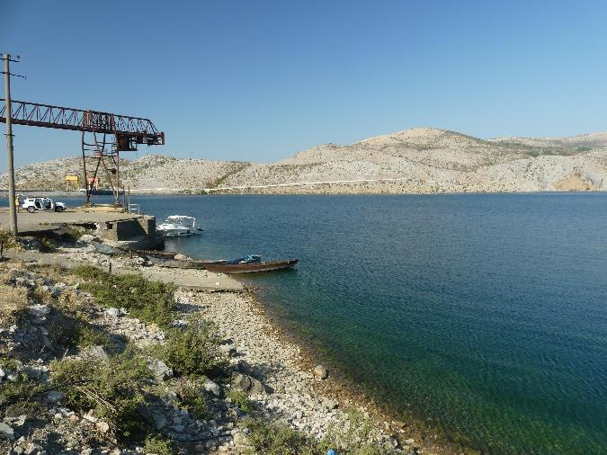

##### Timeline

The preparation of the project is expected to start in 2020 and will extend in 2021, and will focus on the selection, through a competitive bidding process, of the company that will supply and install the floating PV. The contract with this company is planned to be signed in 2021.

The construction activity will last around 8 months. This means that the floating PV would be completed and operational in 2022.

# Legal framework and requirements

The project will be implemented in accordance with laws and regulations in force in the Republic of Albania, as well as EBRD's 2019 environmental and social policy.

## National legislative framework for public consultation and information

The main principles for public participation are stipulated in the Article 23 of the Constitution of the Republic of Albania, which quotes that every person enjoys the guarantee of the right for information. The Republic of Albania also ratified the Aarhus Convention in 2000 (Law No. 8672, dated 26.10.2000, “On the Aarhus Convention Ratification on public right to information, to participate in decision-making and to have access to justice in environmental matters”), which stipulates the public rights on information related to environment, the public rights to participate in environmental decision-making and the right to file complaints when the public perceives that considerations of environmental issues are insufficient.

More specifically, the Project will be subject to an Environmental Impact Assessment under the Albanian legislation and will, for that reason, be subject to public consultations as required and in compliance with the following legislations:

* Law No.10440 ‘On Environmental Impact Assessment, amended by the law no.12/2015: The purpose of this Law is to ensure high level of environmental protection through prevention, minimization and compensation of damage on environment from proposed projects, prior to their approval for development; It guarantee an open decision-making process, in identifying, describing and evaluating adverse environmental impacts, in a timely manner; as well as the involvement of all interest stakeholders.
* DCM no. 686, date 29.7.2015 On approval of Rules, Responsibilities and Timelines for performing EIA procedure and Transfer procedure of Decision of Environmental Declaration: Defines the stakeholders involved in EIA procedure and also the rules, responsibilities and timeline of EIA procedure. A public hearing have to take place according to point 8 of Head II of this DCM. After performing the public meeting based on legislation in force for public information and public involvement in decision-making, the outcomes from public consultation and other involved stakeholders must be reflected in EIA report. All decision made for an EIA process are published on Official Website of MTE and NEA
* DCM No. 247, dated 30.04.2014, “On the determination of the rules and requirements of the procedures for information and involvement of the public in environmental decision making”: Defines the phases for public information and involvement in Preliminary and Full EIA process, the manners and timeline for public opinions before the decision making; the manner and time of public appeal against the acts, actions or non-actions during the procedure of public information and participation in the process of the preliminary EIA or full EIA.

Given the prevalence of the COVID-19 pandemic at the time when this SEP is prepared, the public consultation process will also have to be organized in line with guidelines and protocols deriving from the Ministry of Health and Social Policy in Albania.

## EBRD Requirements

In addition to the requirements of the Albanian legal framework described above, the Project must also meet the requirements for the engagement of stakeholders and environmental and social standards of the EBRD.

All projects financed by EBRD shall be structured to meet the requirements of the EBRD Environmental and Social Policy which includes ten Performance Requirements (PRs) for key areas of environmental and social sustainability that projects are required to meet, including PR10 Information Disclosure and Stakeholder Engagement.  In addition, EBRD’s Independent Project Accountability Mechanism (IPAM), as an independent last resort tool, aims to facilitate the resolution of social, environmental and public disclosure issues raised by Project-affected people and civil society organisations about EBRD financed projects among Project stakeholders or to determine whether the Bank has complied with its ESP and the Project-specific provisions of its Access to Information Policy; and where applicable to address any existing non-compliance with these policies, while preventing future non-compliance by the Bank

EBRD recognizes the importance of stakeholder engagement as an essential element of good international practice and corporate citizenship. Such engagement is also a way of improving the environmental and social sustainability of projects. In particular, effective community engagement is essential for successful management of a project's environmental and social risks and impacts. Stakeholder engagement is central to achieving enhanced community benefits from a project.

The preparation of this SEP has taken into account the provision of EBRD’s Environmental and Social Policy (2019) and the EBRD's Access to Information Policy and Directive (2019). These policies are organized around four key principles that were taken into account when preparing this SEP:

* Transparency
* Accountability.
* Client Responsibility to Affected Stakeholders
* Good Governance

More precisely, the following elements of PR 10 are central to this SEP:

* Stakeholder identification and analysis
* Stakeholder Engagement needs
* The principle of "meaningfulness"
* Availability of a grievance mechanism

# Stakeholders identification and analysis

The objective of stakeholder identification is to establish which individuals, groups or organizations may be directly or indirectly, positively or negatively impacted by the project or interested in the project and to identify the type of information they would need across the Project lifetime.

The identified stakeholders identified be grouped into the following categories:

##### Interested stakeholders

Interested parties are stakeholders who are not directly impacted by the Project, but may have an interest at some stage of its development. These stakeholders would generally want to engage with the Project, and obtain specific information of interest to them. This category covers a wide number of stakeholders, including:

* National, regional or local administrations or state bodies not directly involved in the Project;
* National or regional medias;
* Local businesses that could become suppliers of service or goods;
* Job seekers;
* Civil society organizations involved in social programs or environmental conservation activities in this part of Albania.

##### Potentially affected stakeholders

This category of people who could potentially be impacted by the project includes:

* The Municipality of Vau I Dejes (compatibility of the floating PV with the municipal plans);
* Residents and businesses close to the assembling site (one house and one café);
* Users of the technical building in front of the assembling quay;
* Households and public buildings users located along the access road to supply the work site.
* Users of the reservoir in the projected assembling and installation zone: fishermen, swimmers, boat or jet-ski owners, walkers and tourists.

##### Vulnerable stakeholders

There are in the Project area people who are officially recognized as "vulnerable" due to their personal condition (the Albanian legislation defines the notion of social vulnerability). However, the Project is not expected to significantly or disproportionately impact vulnerable groups, because of its limited social impacts.

There is a slight remaining risk for people who leave along the access road and who would have difficulty to engage or access to information (due to age, disability, education level, ethnicity, social or economic status, etc): these are the persons to be considered as vulnerable in the context of the Project.

# Summary of stakeholder engagement to date

## Stakeholder engagement activities during due diligence

Engagement activities were undertaken during the E&S due diligence process for EBRD and prior to the preparation of the Environmental Impact Assessment, on 22-24 June 2020 and included: a formal meeting with the major and other representatives of Vau i Dejes municipality, individual meeting with other representatives of the municipality and regional stakeholders, focus group discussions with local community and consultation/individual meetings, interviews with community close to the study area.

Interaction with the local government /affected municipality took place at several occasions and for two main purposes: The process comprised the following activities:

* Engagement aimed to present the project and collect views for the project;
* Gathering relevant information on Baseline Conditions of environmental and social resources, identification of issues of concern for affected communities and compatibility with Local General Plan of the Municipality.

A meeting organized by KESH took place at the offices of the hydropower plant on 22nd June, 2020. The major of the municipality and other representatives of the municipality (representatives of urban planning office, public investment office), director of the HPP and representatives from KESH (environmental and technical team) participated to this meeting. A presentation of the project, opportunities and other technical specification was presented.

Focus group discussions with potentially affected stakeholders were conducted on 23 June 2020 at the city of Vau i Dejes. Ten people participated, included mostly unemployed local residents, and also 2 fisherman, 1 state employee and one self-employed. Individual meeting were also held on the field within the small settlements around the reservoir.

The main key concerns and issues raised during stakeholder engagement were taken into account when preparing the project's E&S management plan, and were related to:

* Possible contradiction between the development plan of the municipality and the project;
* Risk of loss of livelihoods for fisherman and loss of aesthetic value (visual impact);
* Safety issues in relation to navigation to the waterway;
* Potential impacts on Tourism and landscape and management to avoid/reduce the impacts – participants were informed that KESH is aware of the Municipal plans, and has engaged with the Municipality to select a preferred option and avoid negative impacts;
* Health and safety.

## Media search

##### Visibility and publicity of the project

The Floating Photovoltaic Plant Project at Vau i Dejes HPP reservoir has been subject to publicity since 2018, which corresponds to the year when the Project was initiated and KESH submitted its application to the Ministry of Infrastructure and Tourism. The news regarding the application have been broadcasted through mass-media including TV stations, news portals as well as social media.

The peak of visibility was at the end of May 2018, and was related to the news that KESH is planning to build a floating photovoltaic plant at Vau i Dejes Reservoir.

The second peak of visibility was at the end of 2018 and beginning of 2019, and was related to the information that KESH had applied nearby the Ministry of Infrastructure and Energy, in early December 2018, for the approval in principal of an investment of a floating photovoltaic plant of circa 12 ha and capacity production of 12.9 MWH.

The third and latest peak of news on the floating PV plant in Vau i Dejes occurred in early February 2020 when the Energy Regulator Entity (ERE) took a decision concerning the price of electricity produced by photovoltaics.

##### Visibility and publicity of the Vau i Dejes Reservoir

The reservoir of Vau i Dejes has been created in the late 1960’s as result of the building of a Hydropower Plant (HPP) in Drin river. Vau i Dejes HPP is the first of the three HPPs built over Drin river, the main source of electrical energy production for Albania.

Almost forgotten in the past, the reservoir has seen a recent rise of attention towards tourism, agrotourism as well as historical heritage in relation to Dania, Sarda and Komani historical towns.

Most recently, end of June 2020, the Albanian State Television has broadcasted a documentary about the municipality of Vau i Dejes and its tourism values. The potential of the reservoir for tourism development has been highlighted and information was provided on local tourism initiatives including those located in Gomsiqe Bay, Lisna agritourism and Shurdhahu island or the former medieval town of Sarda as well as Koman, with the latter known by archaeologists and historians as a very important site for Illyrian culture.

Recent mass media news have highlighted particularly the use of reservoir for navigation and tourism with Vau i Dejes municipality considering the potential for navigation through the lake as a very important asset for the economic development of the area.

Figure 3 - Tourism sites related to Vau I Dejes reservoir mentioned in medias

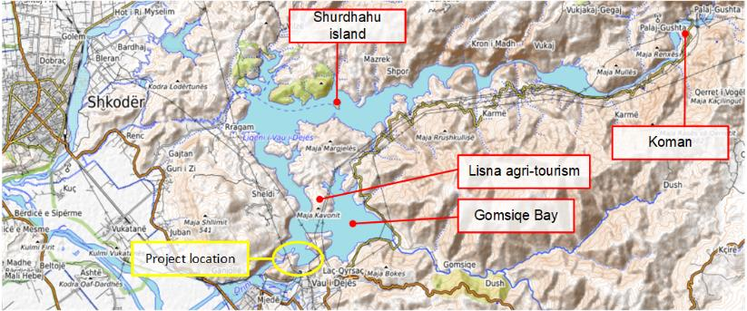

# Documents/information disclosure and engagement activities

The following table introduce a summary of stakeholder groups identified to-date, the purpose of engagement and communication method that will be used from project promoter (KESH) and timing of engagement. The Plan must be reviewed annually and updated if needed to ensure transparent and meaningful engagement with stakeholders.

Table 1 - Stakeholder engagement activities

| # | Stakeholders | Type of information disclosure / engagement | Media | Timeline (Responsible party) |
| --- | --- | --- | --- | --- |
| 1 | Potentially affected households and neighbouring communities:   * Residents of Vau I Dejes city, Gomsiqe e Poshtme and Sheldie villages * Households that live, possess or use assets close to the Project area | General information about the Project, and company's contact for more information | Preparation of a dedicated Project Webpage for the floating PV (within KESH website, or as a separate website) | Before project starts and prior to financial agreement signing  (KESH ESAP owner) |
| 2 | Disclosure of the NTS, ESAP and SEP on the Project Webpage for life of Project |
| 3 | Public information meeting in Vau I Dejes (30' presentation + 30' questions and answers) |
| 4 | Regional mass media | Information on project | Press release with the NTS | Before project starts  (KESH ESAP owner) |
| 5 | Municipality of Vau I Dejes | Agreement between KESH and Vau I Dejes Municipality, in order to ensure a good integration of the floating PV with the Municipality Territorial Development Plan. The agreement must be legally binding, include a clear description of the design criteria to be met to ensure the compatibility of the floating PV and Municipal plan, and a description of the respective obligations and commitments of KESH and the Municipality for the integration of the two projects. | Meeting between KESH and the Municipality | Prior to construction permit application and prior to completion of detailed design  (KESH ESAP owner) |
| 6 | Reservoir users | Information sharing and awareness raising about of biodiversity conservation features in Vau i Dejes reservoir. | Information boards presenting the species of conservation interest of Vau I Dejes reservoir and conservation/protection status: one board at the construction quay area , and one at the large Gomsiqe bay cafe (cafe Perla). The information boards must be designed to be long lasting. | Boards installed during construction and maintained across operation  (KESH ESAP owner) |
| 7 | Regional entities with a relation or interest in reservoir biodiversity:  Vau I Dejes citizen, the regional envt agency from Shkodra, Regional Agency for Protected Areas (Shkodra), the basin agency from Shkodra, aquaculture producers, nature conservation CSOs. | At the public meeting planned in Vau I Dejes town to present  the floating PV to the following stakeholder. | Prior to completion of detailed design  (KESH ESAP owner) |
| 8 | National entities interested in biodiversity conservation: Ministry in charge of Environment (MoE) , the National Environmental Agency, National Agency for Protected Areas (under MoE), universities, and nature conservation CSOs | In Tirana to the Ministry in charge of Environment MoE , the National Envt agency (under MoE), universities, and nature conservation CSOs. | Prior to completion of detailed design  (KESH ESAP owner) |
| 9 | All stakeholders | Public consultation process as required by the national legislation | Public meetings – adapted to the Covid-19 situation | As required by the legislation  (KESH ESAP owner) |
| 10 | Project implementation report: disclosure of a simplified E&S report summarizing: biodiversity monitoring; E&S statistics, complaints. | On the dedicated Webpage for the floating PV | Annually  (KESH ESAP owner) |
| 11 | Vulnerable stakeholders nearby the project area (Women headed household; Elderly people; Person with disabilities; etc..) | Specific information needs or medias | Door to door meetings and identification of vulnerable persons living among the road from Vau I Dejes centre to the project assembling site. Identification of specific supplementary actions required to mitigate risks generated by the Project to the vulnerable stakeholders.  Weekly check-in with the household and café close to the floating PV assembling site | At the beginning of project construction  (KESH SEO) |
| 12 | Potential suppliers and service providers | Information about the Project procurement, and company's contact for more information | Information about procurement for potential suppliers on the Project Webpage | During construction  (KESH ESAP owner) |
| 13 | Jobseekers | Information about employment opportunities | Information about the place where jobs are announced on the Project Webpage | During construction  (KESH ESAP owner) |
| 14 | City road police | Planned traffic disturbances or heavy load convoys (if any) | Formal correspondence and meetings | 5 days before disturbance  (KESH SEO) |

# Arrangements for stakeholders engagement

## Organisation

To ensure continuous and systematic communication with stakeholders of the project, KESH will designate a Stakeholder Engagement Officer (SEO).

The SEO does not need to be a full-time position, but the responsibility must be assigned, for example to the same person in charge of the Environmental and Social Action Plan (ESAP) implementation. He/she will regularly update this SEP and will provide information, collect feedback and respond to stakeholders on how this has been considered, as well as provide answers to incoming communications (via email, telephone or in person).

The SEO will organize and coordinate the preparation of the website and communication tools for the Project.

The SEO will identify points of contact in the popular regional newspapers, radio and TV channels, provide them with initial project information and include them in the mailing list about future events.

The SEO will establish email contact with representatives of the environmental and social CSOs that would express interest in the Project, and will provide them with initial information on the project and include them to the mailing list.

The SEO will perform the following functions:

* Ensure implementation of the activities described in Table 1
* Annual monitoring of the effectiveness of the stakeholder engagement plan and grievance mechanism, and update if necessary;
* Monitoring and updating the web page;
* Participation in grievances resolution;
* Assistance in the annual report preparation and the environmental and social action plan implementation.

## Internal monitoring and reporting

The SEO will hold a "stakeholder engagement database" in a simple tabular format:

Table 2 - Stakeholder engagement database

|  |  |  |  |  |  |  |
| --- | --- | --- | --- | --- | --- | --- |
| # | Name / address | Question /Grievance | Answer method | Answer | Status | Is response satisfying |
| Date01 |  |  |  |  | reply date, closed etc. | yes, no |
| Date02 |  |  |  |  |  |  |

The SEO will also organize and monitor the effective implementation of the SEP and will provide quarterly reporting to KESH.

Quarterly reporting will include:

* Description of Stakeholder Engagement Plan actions undertaken during the reporting period, with reference to the SEP;
* Statistics for the reporting period (using the database):
* Number of visits to the website
* Number of queries received by phone, email or directly at the company premises.
* Main topics of queries
* Number of grievances
* Main topics of grievances

## Grievance redress mechanism

The objective of the grievance redress mechanism is to resolve problems in a timely and amicable manner, in order to avoid time- and resource-consuming court process. It is open to any citizen or worker.

The SEO will register all grievances in the stakeholder engagement database (Table 2). The database is for controlling the grievance handling process. This mechanism does not limit the public’s rights to use the conventional routes to place grievances and the available legal system. Depending on the nature and status of the query or complaint, the SEO will decide whether it has to be treated as a grievance, as per the flowchart below.

The grievance flow chart to be used for the construction period is provided in the following figure. After construction, grievances will be managed through KESH's corporate grievance mechanism.

Figure 4 - Grievance mechanism

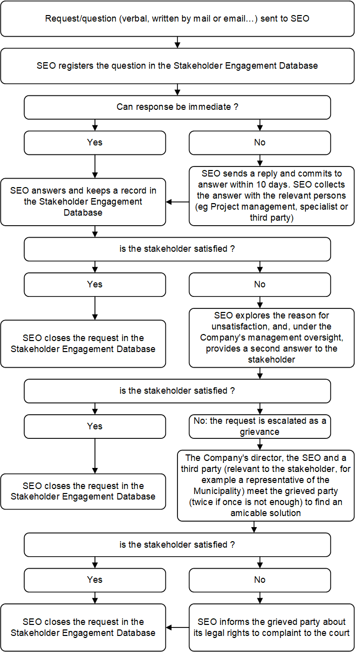

1. Grievance Form

|  |  |  |  |  |
| --- | --- | --- | --- | --- |
| **GRIEVANCE FORM**  Reference No: | | | | |
| Full Name  Note: *you can remain anonymous if you prefer or request not to disclose your identity to the third parties without your consent* | My first name \_\_\_\_\_\_\_\_\_\_\_\_\_\_\_\_\_\_\_\_\_\_\_\_\_\_\_\_\_\_\_\_\_\_\_\_\_  My last name \_\_\_\_\_\_\_\_\_\_\_\_\_\_\_\_\_\_\_\_\_\_\_\_\_\_\_\_\_\_\_\_\_\_\_\_\_   I wish to raise my grievance anonymously    I request not to disclose my identity without my consent | | | |
| Contact Information  Please mark how you wish to be contacted (mail, telephone, e-mail). | By Post: Please provide mailing address: \_\_\_\_\_\_\_\_\_\_\_\_\_\_\_\_\_\_\_\_\_\_\_\_\_\_\_\_\_\_\_\_\_\_\_\_\_\_\_\_\_\_\_\_\_\_\_\_\_\_\_\_\_\_\_\_\_\_\_\_\_\_\_\_\_\_\_\_\_\_\_\_\_\_\_\_\_\_\_\_\_\_\_\_\_\_\_\_\_\_\_\_\_\_\_\_\_\_\_\_\_\_\_\_\_\_\_\_\_\_\_\_\_\_\_\_\_\_\_\_\_\_\_\_\_\_\_\_\_\_\_\_\_\_\_\_\_\_\_\_\_\_\_\_\_\_\_\_\_\_\_\_\_\_\_\_\_\_\_\_\_\_\_\_\_\_\_\_\_\_\_  By Telephone: \_\_\_\_\_\_\_\_\_\_\_\_\_\_\_\_\_\_\_\_\_\_\_\_\_\_\_\_\_\_\_\_\_\_\_\_\_\_\_\_\_  By E-mail \_\_\_\_\_\_\_\_\_\_\_\_\_\_\_\_\_\_\_\_\_\_\_\_\_\_\_\_\_\_\_\_\_\_\_\_\_\_\_\_\_\_\_\_\_\_\_ | | | |
| Preferred Language for communication | Albanian  English  Other: | | | |
| Description of Incident or Grievance: | | | What happened? Where did it happen? Who did it happen to? What is the result of the problem? | |
|  | | | | |
| Date of Incident/Grievance | |  | | |
|  | | One-time incident/grievance (date \_\_\_\_\_\_\_\_\_\_\_\_\_\_\_)  Happened more than once (how many times? \_\_\_\_\_)  On-going (currently experiencing problem) | | |
| What would you like to see happen to resolve the problem? | | | |  |
|  | | | | |

Signature: Date:

Please return this form to the SEO [name and contact details]